**E-learning solutions**

An [online](https://simple.wikipedia.org/wiki/Online) [educational](https://simple.wikipedia.org/wiki/Education) or e-learning service is a [website](https://simple.wikipedia.org/wiki/Website) which [teaches](https://simple.wikipedia.org/wiki/Teach) and helps [students](https://simple.wikipedia.org/wiki/Student) improve in various subjects. Educational technology creates, uses, and manages technological processes and educational resources to help improve user academic performance. The field has been described as a persisting initiative that seeks to bring learners, teacher, and technical means together in an effective way.

A learning management system (LMS) is a [software application](https://en.wikipedia.org/wiki/Software_application) for the administration, documentation, tracking, reporting, and delivery of [educational](https://en.wikipedia.org/wiki/Educational) courses, training programs, or learning and development programs.

There are a variety of eLearning platforms and learning management systems that makes advanced training easy and accessible.

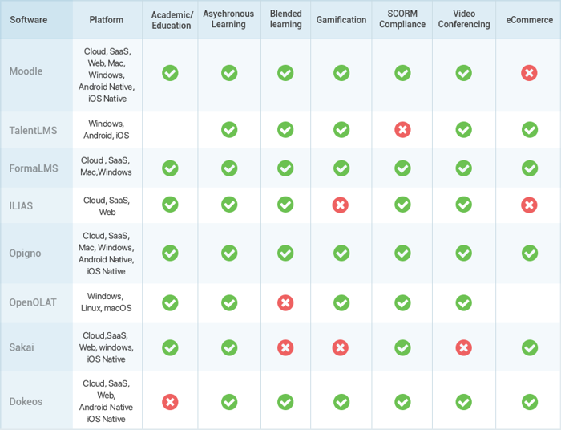

# edX and Open edX

## Overview

edX is the trusted platform for education and learning.

They are founded by and continue to be governed by colleges and universities. They are the only leading Massive Open Online Courses provider that is both nonprofit and open source.

The Open edX project is a web-based platform for creating, delivering, and analyzing online courses. It is the software that powers edx.org and many other online education sites.

The centerpiece of the Open edX architecture is [edx-platform](https://github.com/edx/edx-platform), which contains the learning management and course authoring applications (LMS and Studio, respectively).

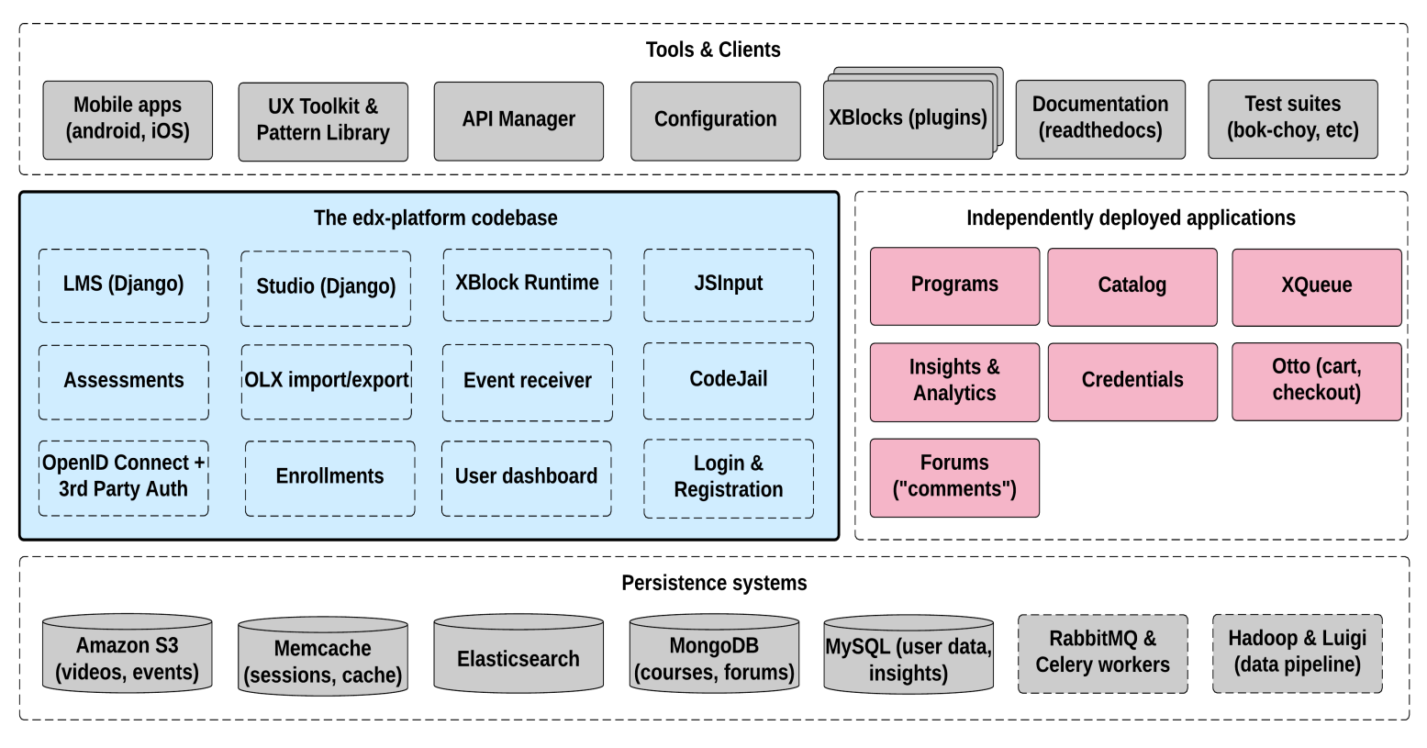

This service is supported by a collection of other autonomous web services called independently deployed applications (IDAs).

Almost all of the server-side code in the Open edX project is in [Python](https://www.python.org/), with [Django](https://www.djangoproject.com/) as the web application framework.

## Key Components

### Learning Management System (LMS)

The LMS is the most visible part of the Open edX project. Learners take courses using the LMS. The LMS also provides an instructor dashboard that users who have the Admin or Staff role can access by selecting **Instructor**.

The LMS uses a number of data stores. Courses are stored in [MongoDB](http://www.mongodb.org/), with videos served from YouTube or Amazon S3. Per-learner data is stored in MySQL.

As learners move through courses and interact with them, events are published to the analytics pipeline for collection, analysis, and reporting.

#### Front End

The Django server-side code in the LMS and elsewhere uses [Mako](http://www.makotemplates.org/) for front-end template generation. The browser-side code is written primarily in JavaScript with some [CoffeeScript](http://coffeescript.org/) as well. Parts of the client-side code use the [Backbone.js](http://backbonejs.org/) framework. The Open edX project uses [Sass](http://sass-lang.com/) and the [Bourbon framework](http://bourbon.io/) for CSS code.

#### Course Browsing

The Open edX project provides a simple front page for browsing courses. The [edx.org](http://edx.org/) site has a separate home page and course discovery site that is not open source.

#### Course Structure

Open edX courses are composed of units called [XBlocks](https://open.edx.org/xblocks). Anyone can write new XBlocks, allowing educators and technologists to extend the set of components for their courses. The edX platform also still contains several XModules, the precursors to XBlocks.

In addition to XBlocks, there are a few ways to extend course behavior:

* The LMS is an [LTI](https://open.edx.org/learning-tools-interoperability) tool consumer. Course authors can embed LTI tools to integrate other learning tools into an Open edX course.
* Problems can use embedded Python code to either present the problem or assess the learner’s response. Instructor-written Python code is executed in a secure environment called CodeJail.
* JavaScript components can be integrated using [JS Input](https://open.edx.org/js-input).
* Courses can be exported and imported using OLX (open learning XML), an XML- based format for courses.

### Studio

Studio is the course authoring environment. Course teams use it to create and update courses. Studio writes its courses to the same Mongo database that the LMS uses.

# [TalentLMS](https://www.goodfirms.co/software/talent-lms)

TalentLMS is a cloud-based learning platform that helps small and medium sized organizations train their employees and customers. Users can create courses using their own videos, presentations and documents, or use publicly available content from the web. TalentLMS makes effective usage of time and maximizes training output by eliminating unnecessary functionality and emphasizing the reuse of existing training material. TalentLMS offers a REST for programmatic access to the platform. API resources include users, courses, categories, groups, and branches. An API key is required.

They use **Amazon** as their infrastructure provider. They rely on **Amazon S3** for storing eLearning content securely, and they use **Amazon CloudFront** to distribute it. They also use **Sparkpost** to handle transactional emails and some optional services like **Stripe** to handle payments.

**Contingency plan**

All user files are stored on Amazon S3 which is designed for durability of 99.999999999% of objects. All data is redundantly stored across multiple facilities and multiple devices in each facility.

Databases are backed-up daily and stored for 30 days on a separate infrastructure. We also keep full virtual machines for all database servers as a quick way to restore the service in case of catastrophic failure.

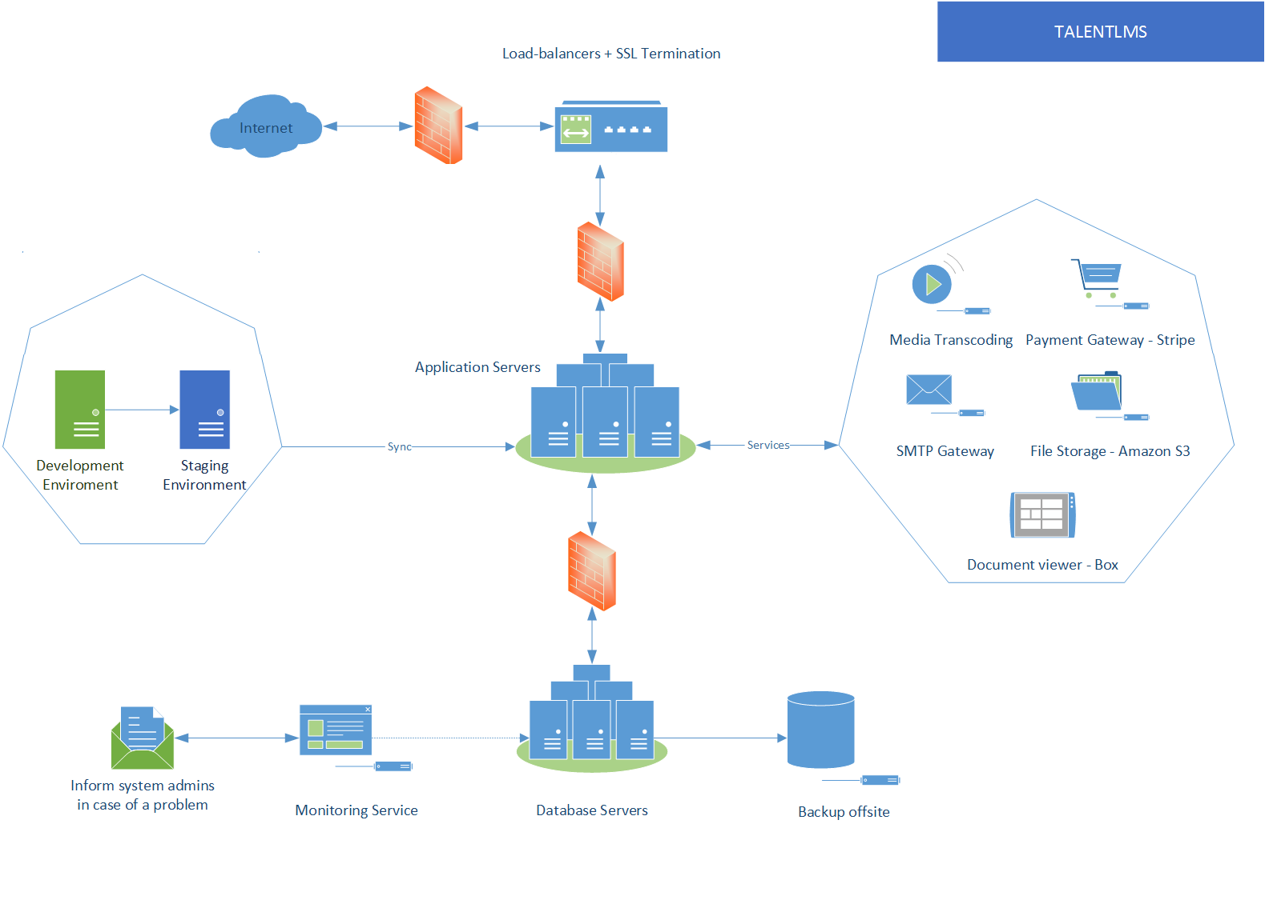

# Moodle

Moodle in a LMS and an open source web application written in PHP.

Moodle is structured as an application core, surrounded by numerous plugins to provide specific functionality.

## Overview

Moodle core provides all the infrastructure necessary to build a Learning Management System. It implements the key concepts that all the different plugins will need to work with. These include: courses and activities, users, course enrolment, user functionality (roles, capabilities, context, permissions), creation and editing of user profiles, groups, enrolments and access control.

Activity and course completion: The activity completion system allows activities such as Quizzes, SCORM modules, etc. to be marked complete when specified conditions are met.

Navigation, settings and configuration: The Navigation block provide easy access to view various sections of the Moodle site and includes:

* My home - a personalised home page displaying links to the courses a user is associated with and activity information (such as unread forum posts and upcoming assignments)
* Site pages - links to site pages and resources from the front page of Moodle
* My profile - quick links allowing a user to view their profile, forums posts, blogs and messages as well as manage their private files
* My courses - lists (by course shortname) and links to courses the user is associated with. Click the course's shortname to view the front page of the course or use the arrows to navigate quickly to a specific section, resource or activity.

Moodle has adopted the Yahoo User Interface library. There is also a nice system for loading the additional JavaScript files required by each page.

# Other eLearning platforms: Coursera, Udemy, [LearnWorlds](https://www.learnworlds.com/online-learning-platforms/#LearnWorlds), Skillshare, [Thinkific](https://www.learnworlds.com/online-learning-platforms/#Thinkific), [Teachable](https://www.learnworlds.com/online-learning-platforms/#Teachable) etc.